AI & ML: Core Concepts and Foundations

CHAPTER 1: What is Artificial Intelligence?
Artificial Intelligence is defined and categorized across two main dimensions:

- Human Performance vs. Rationality

- Thought vs. Action

Combining these dimensions yields four distinct approaches to AI:
ACTION

1. Acting Humanly: The Turing Test Approach
A computer passes the Turing Test if a human interrogator, after posing written questions, cannot distinguish whether the responses came from a human or a computer.

To pass the standard Turing Test, an AI system requires:

- Natural Language Processing (NLP): To communicate fluently in human languages.

- Knowledge Representation: To store facts and sensory inputs efficiently.

- Automated Reasoning: To draw logical conclusions and answer queries.

- Machine Learning: To adapt to new situations and detect structural patterns.

The Total Turing Test
To account for visual and physical interactions in the real world, the Total Turing Test adds two requirements:

- Computer Vision & Speech Recognition: To perceive physical objects, surroundings, and spoken audio.

- Robotics: To manipulate physical objects and navigate spatial environments.

2. Thinking Humanly: The Cognitive Modeling Approach
To construct systems that emulate human cognition, we must first model human brain processes. Cognitive science determines human thought mechanisms through three primary methods:

- Introspection: Capturing internal thought processes directly during cognitive tasks.

- Psychological Experiments: Observing human behavioural responses to specific tasks.

- Brain Imaging: Measuring real-time neurobiological activity via functional imaging (e.g., fMRI).

3. Thinking Rationally: The "Laws of Thought" Approach
This approach relies on formal mathematical logic and inference rules to guarantee correct conclusions from given premises.

- Classical Logic Example (Syllogism):

  - Premise 1: All humans are mortal.

  - Premise 2: Socrates is a human.

  - Conclusion: Therefore, Socrates is mortal.

4. Acting Rationally: The Rational Agent Approach
An agent is an entity that perceives and acts upon an environment. A rational agent selects actions designed to achieve the best expected outcome based on its current percept history and environmental constraints.

CHAPTER 2: Intelligent Agents

2.1 Basic Definitions
- Agent: An entity that perceives its environment through sensors and acts upon that environment via actuators.

- Percept Sequence: The complete chronological history of every sensory input perceived by the agent to date.

- Agent Function ($f$): An abstract mathematical mapping from any given percept sequence to a specific action:

$$f:P^{*}→A$$
- Agent Program: The concrete software implementation of the agent function running on physical hardware (architecture).

┌───────────────────────────────────────┐

2.2 Rationality vs. Omniscience
- Rationality: Maximizes expected performance based on the agent's percept history, knowledge base, and actionable choices.

- Omniscience: Refers to knowing the actual, deterministic outcome of an action in advance. Omniscience is physically impossible in non-deterministic environments; rationality focuses on optimal decision-making under uncertainty rather than absolute perfection.

2.3 The PEAS Framework
Before designing an agent, its high-level specifications must be structured using the PEAS (Performance, Environment, Actuators, Sensors) framework:

PEAS Element | Definition | Self-Driving Car Example
Performance Measure | Objective metric to evaluate agent success | Safety, velocity, legal compliance, comfort, fuel efficiency
Environment | The external system or domain in which the agent operates | Urban roads, highways, traffic, pedestrians, weather conditions
Actuators | Physical/digital mechanisms used to execute actions | Steering assembly, throttle control, braking system, indicators
Sensors | Physical/digital hardware used to collect percepts | Cameras, LIDAR, RADAR, GPS, speedometers, IMU sensors

2.4 Environment Classifications
Dimension | Binary Classification | Structural Definition | Technical Example
Visibility | Fully Observable vs. Partially Observable | Complete state captured by sensors vs. noisy/incomplete state data. | Chess vs. Autonomous Driving
Predictability | Deterministic vs. Stochastic | Next state determined strictly by current state + action vs. probabilistic outcomes. | Crossword vs. Traffic Navigation
Structure | Episodic vs. Sequential | Current choice does not influence future states vs. current actions dictate all future states. | Defect Inspection vs. Chess
Dynamics | Static vs. Dynamic | Environment remains frozen during deliberation vs. environment continuously evolves. | Sudoku vs. Real-time Driving
Domain | Discrete vs. Continuous | Finite state/action transitions vs. continuous mathematical functions across time. | Board Games vs. Vehicle Control

2.5 Agent Architectures

1. Simple Reflex Agent
- Mechanism: Selects actions strictly on the current percept using hardcoded Condition-Action (IF-THEN) rules. Operates without percept history or state tracking.

- Example: Automatic Motion-Sensor Light Controller

  - Rule: IF motion_detected == True THEN trigger_actuator(Light_ON)

2. Model-Based Reflex Agent
- Mechanism: Maintains an explicit internal state (world model) to track unobserved aspects of partially observable environments over time.

- Example: Robotic Vacuum Cleaner

  - Function: Tracks unexplored areas, obstacle coordinates, and cleaning state using internally stored spatial maps.

3. Goal-Based Agent
- Mechanism: Integrates internal state tracking with explicit goal configurations. Evaluates future state outcomes via planning and search algorithms to formulate action sequences toward its objective.

- Example: GPS Navigation System

  - Function: Formulates precise turn-by-turn routes by evaluating path sequences to reach specified destination coordinates.

4. Utility-Based Agent
- Mechanism: Employs a mathematical utility function ($U\left(s\right)$) to compute a scalar measure of performance/desirability for competing goals or multi-criterion path trajectories under uncertainty.

- Example: Ride-Hailing Matching & Routing Systems

  - Function: Optimizes route Selection by calculating trade-offs between transit duration, financial cost, and route reliability.

5. Learning Agent
- Mechanism: Operates in unknown or changing environments, continuously modifying its decision rule capabilities through explicit performance feedback.

- Architectural Components:

  - Performance Element: Processes sensory input and executes outward actions.

  - Critic: Evaluates agent behavior against a fixed performance standard.

  - Learning Element: Modifies the decision rules within the Performance Element based on Critic feedback.

  - Problem Generator: Suggests exploratory actions to collect new observational data.

- Example: Media Recommendation Engine

  - Function: The Performance Element presents content, the Critic tracks engagement parameters (e.g., watch time, skips), the Learning Element updates preference vectors, and the Problem Generator suggests novel genres to discover user preferences.

2.6 Five Agent Architectures Components

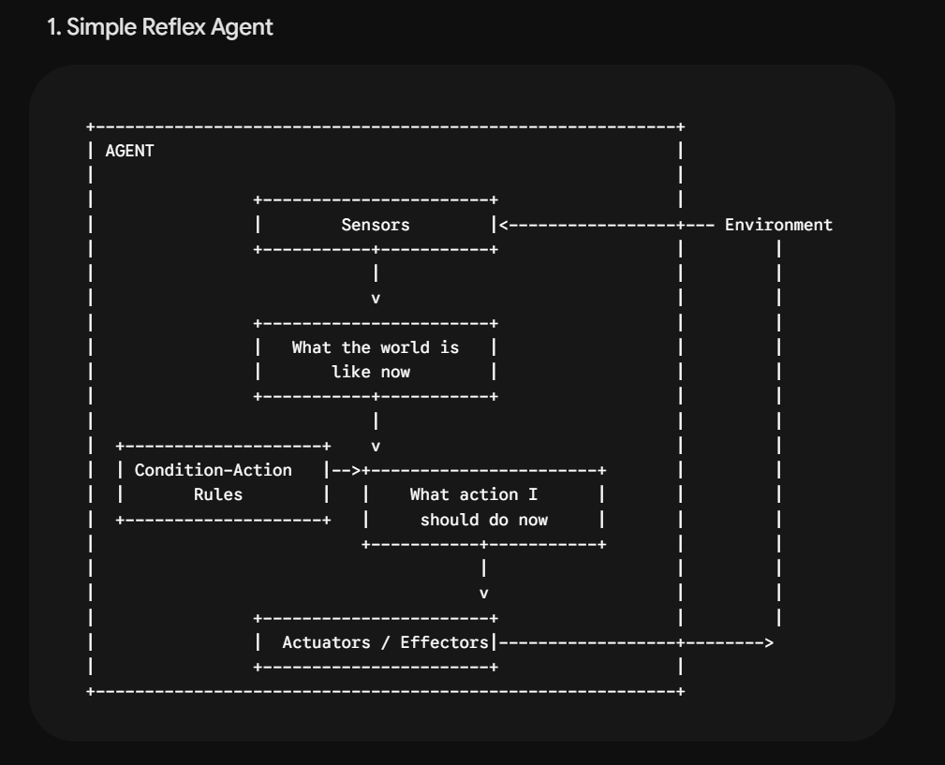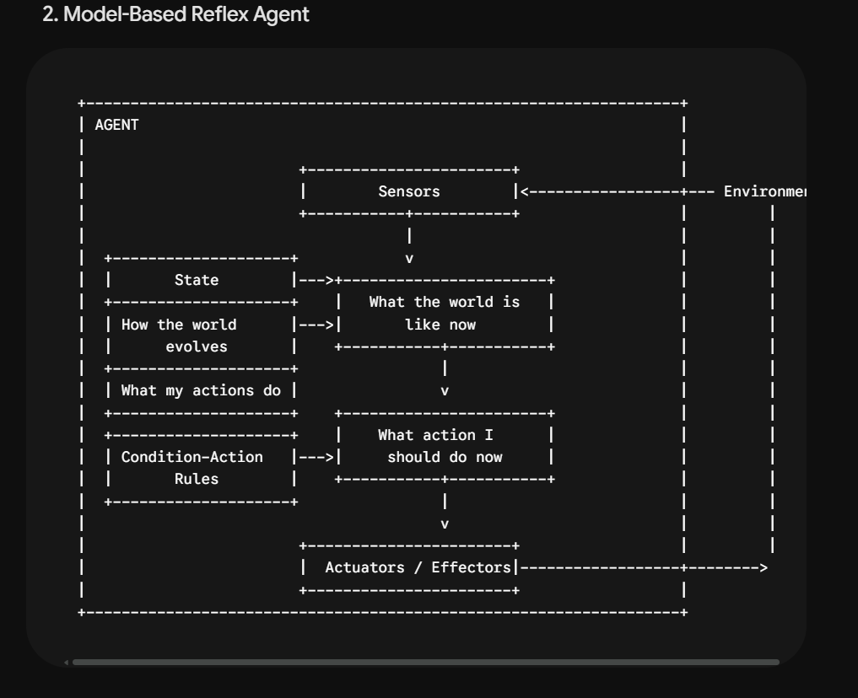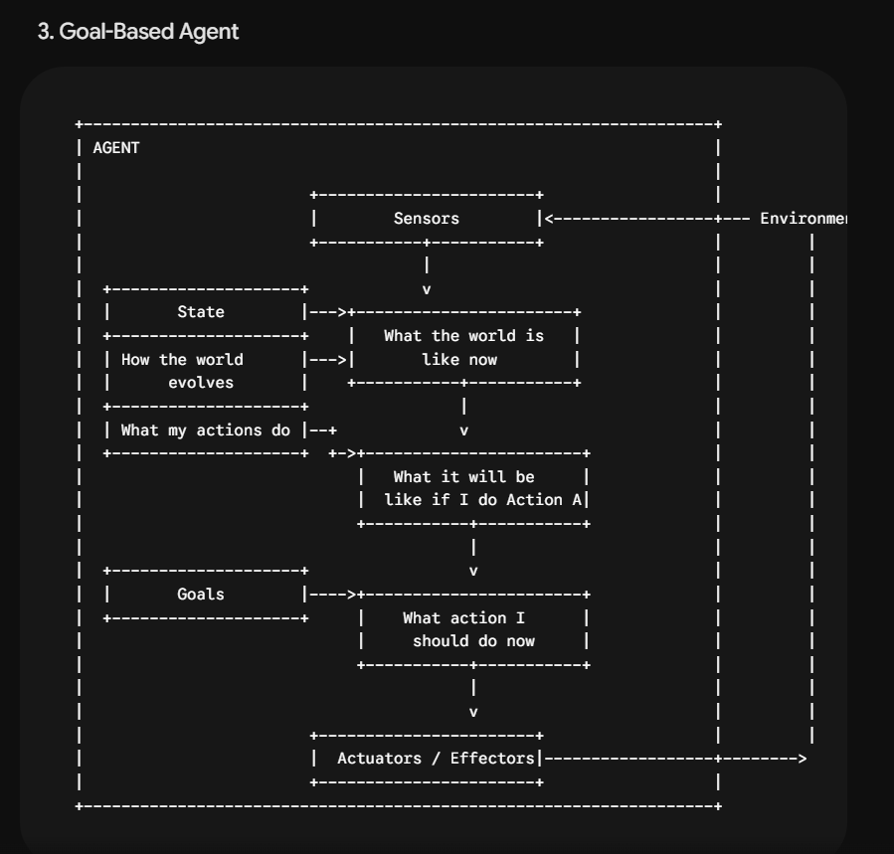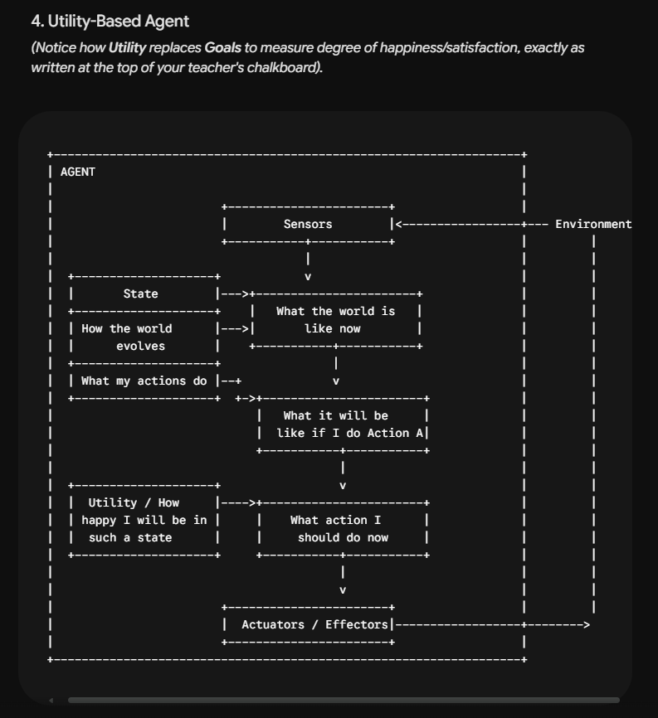

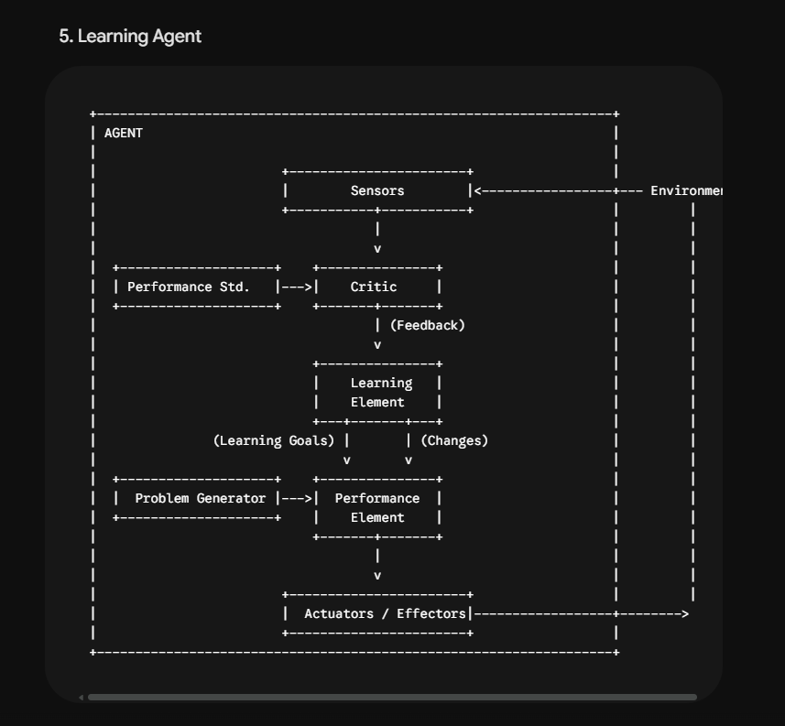

CHAPTER 2: Intelligent Agents

2.1 Basic Definitions
- Agent: An entity that perceives its environment through sensors and acts upon that environment via actuators.

- Percept Sequence: The complete chronological history of every sensory input perceived by the agent to date.

- Agent Function ($f$): An abstract mathematical mapping from any given percept sequence to a specific action:

$$f:P^{*}→A$$
- Agent Program: The concrete software implementation of the agent function running on physical hardware (architecture).

┌───────────────────────────────────────┐

2.2 Rationality vs. Omniscience
- Rationality: Maximizes expected performance based on the agent's percept history, knowledge base, and actionable choices.

- Omniscience: Refers to knowing the actual, deterministic outcome of an action in advance. Omniscience is physically impossible in non-deterministic environments; rationality focuses on optimal decision-making under uncertainty rather than absolute perfection.

2.3 The PEAS Framework
Before designing an agent, its high-level specifications must be structured using the PEAS (Performance, Environment, Actuators, Sensors) framework:

PEAS Element | Definition | Self-Driving Car Example
Performance Measure | Objective metric to evaluate agent success | Safety, velocity, legal compliance, comfort, fuel efficiency
Environment | The external system or domain in which the agent operates | Urban roads, highways, traffic, pedestrians, weather conditions
Actuators | Physical/digital mechanisms used to execute actions | Steering assembly, throttle control, braking system, indicators
Sensors | Physical/digital hardware used to collect percepts | Cameras, LIDAR, RADAR, GPS, speedometers, IMU sensors

2.4 Environment Classifications
Dimension | Binary Classification | Structural Definition | Technical Example
Visibility | Fully Observable vs. Partially Observable | Complete state captured by sensors vs. noisy/incomplete state data. | Chess vs. Autonomous Driving
Predictability | Deterministic vs. Stochastic | Next state determined strictly by current state + action vs. probabilistic outcomes. | Crossword vs. Traffic Navigation
Structure | Episodic vs. Sequential | Current choice does not influence future states vs. current actions dictate all future states. | Defect Inspection vs. Chess
Dynamics | Static vs. Dynamic | Environment remains frozen during deliberation vs. environment continuously evolves. | Sudoku vs. Real-time Driving
Domain | Discrete vs. Continuous | Finite state/action transitions vs. continuous mathematical functions across time. | Board Games vs. Vehicle Control

2.5 Agent Architectures

1. Simple Reflex Agent
- Mechanism: Selects actions strictly on the current percept using hardcoded Condition-Action (IF-THEN) rules. Operates without percept history or state tracking.

- Example: Automatic Motion-Sensor Light Controller

  - Rule: IF motion_detected == True THEN trigger_actuator(Light_ON)

2. Model-Based Reflex Agent
- Mechanism: Maintains an explicit internal state (world model) to track unobserved aspects of partially observable environments over time.

- Example: Robotic Vacuum Cleaner

  - Function: Tracks unexplored areas, obstacle coordinates, and cleaning state using internally stored spatial maps.

3. Goal-Based Agent
- Mechanism: Integrates internal state tracking with explicit goal configurations. Evaluates future state outcomes via planning and search algorithms to formulate action sequences toward its objective.

- Example: GPS Navigation System

  - Function: Formulates precise turn-by-turn routes by evaluating path sequences to reach specified destination coordinates.

4. Utility-Based Agent
- Mechanism: Employs a mathematical utility function ($U\left(s\right)$) to compute a scalar measure of performance/desirability for competing goals or multi-criterion path trajectories under uncertainty.

- Example: Ride-Hailing Matching & Routing Systems

  - Function: Optimizes route Selection by calculating trade-offs between transit duration, financial cost, and route reliability.

5. Learning Agent
- Mechanism: Operates in unknown or changing environments, continuously modifying its decision rule capabilities through explicit performance feedback.

- Architectural Components:

  - Performance Element: Processes sensory input and executes outward actions.

  - Critic: Evaluates agent behavior against a fixed performance standard.

  - Learning Element: Modifies the decision rules within the Performance Element based on Critic feedback.

  - Problem Generator: Suggests exploratory actions to collect new observational data.

- Example: Media Recommendation Engine

  - Function: The Performance Element presents content, the Critic tracks engagement parameters (e.g., watch time, skips), the Learning Element updates preference vectors, and the Problem Generator suggests novel genres to discover user preferences.

3.Problem Structuring, Classification & Modeling

1. Well-Structured vs. Ill-Structured Problems
- Well-Structured Problems (Predictable):

  - Definition: Problems that yield a single definite right answer or inference when an appropriate algorithm is applied.

  - Characteristics: Clear, objective evaluation criteria exist; executed through ordered steps; yields binary test outcomes (Correct or Incorrect); allows abstraction and generalization across similar problems.

  - Examples:

    - Quadratic Equation: Solving $ax^{2}+bx+c=0$ yields a specific mathematical answer.

    - Missile Trajectory: Calculating paths governed strictly by physics laws yields precise results.

    - Tic-Tac-Toe: Classic game with a 9-position state space, clear rules, and an optimal solution.

- Ill-Structured Problems (Context-Dependent):

  - Definition: Problems that do not yield a single particular answer; a specific situation determines correctness.

  - Characteristics: Multiple valid answers exist; no fixed algorithm or ordered steps; evaluation is non-binary and context-dependent; requires high problem-specific intelligence, making generalization difficult.

  - Examples:

    - Wet Waste Disposal: Safe disposal procedures depend on environmental conditions and local regulations.

    - Theoretical Prepositions: Analyzing theoretical propositions varies by scenario and personal judgment.

    - Security Threats: Identifying risks in large social gatherings deals with evolving conditions without a single right answer.

2. Decision Space: Linear vs. Non-Linear Problems
- Linear Problems:

  - Definition: Problems where inputs and outputs maintain a linear relationship, having either a definite solution or no solution.

  - Characteristics: Decisions can be separated using simple linear classification functions (linear separability). Straightforward to solve and generalize.

  - Real-World Application: Text classification.

- Non-Linear Problems:

  - Definition: Problems where relationships between inputs and outputs are non-linear, requiring transformations to find solutions.

  - Characteristics: Decisions cannot be separated by simple linear functions (non-linear separability). Involves complex generalization steps.

  - Real-World Application: Image and speech recognition.

3. Summary Table: Problem Structures
Criteria | Well-Structured | Ill-Structured | Linear | Non-Linear
Answer | Definite right answer | Multiple answers possible | Definite or none | Requires transformation
Algorithm | Specific algorithm applies | No fixed algorithm | Classification function | Non-linear transformation
Evaluation | Clear, objective criterion | Context-dependent | Linear separability | Non-linear separability
Generalisation | Possible via similarities | Difficult to generalise | Straightforward | Complex
Real-world use | Math, physics, networks | Security, policy, health | Text classification | Image, speech recognition

The 5 Components of Problem Formulation
To turn a real-world problem into something an algorithm can solve, you must explicitly define five parameters:
- Initial State: The state where the agent starts.
- Actions ($Actions\left(s\right)$): The set of valid actions available to the agent when in state $s$.
- Transition Model ($Result\left(s,a\right)$): A function that returns the state $s'$ resulting from executing action $a$ in state $s$.
- Goal Test: A boolean function determining whether a given state $s$ satisfies the objective.
- Path Cost ($c\left(s,a,s'\right)$): A function that assigns a numeric cost to taking action $a$ to transition from state $s$ to $s'$.

What is State Space Search?
- State Space: The set of all possible states reachable from the initial state by applying any sequence of actions.
- State Space Graph: A conceptual graph where Nodes = States and Directed Edges = Actions.
- Search Tree: The explicit tree formed when a search algorithm explores the graph step-by-step from the initial state.
- State Space Search: The systematic traversal of the search tree from the root (initial state) until a node satisfying the Goal Test is found.

Concrete Visual Example: The 8-Puzzle
Consider the classic 8-Puzzle (a $3×3$ grid with 8 numbered tiles and 1 empty blank space).

1. Formalizing the 8-Puzzle
- Initial State: Any starting board configuration (e.g., blank tile at bottom-right).
- Actions: Move blank $\left\{\text{Left},\text{Right},\text{Up},\text{Down}\right\}$ (subject to board boundary limits).
- Transition Model: $Result\left(\text{Board Configuration},\text{Move Blank Up}\right)→\text{New Board Configuration}$.
- Goal Test: Does current board layout match $\left[\begin{matrix}1 & 2 & 3 \\ 4 & 5 & 6 \\ 7 & 8 & \text{_}\end{matrix}\right]$?
- Path Cost: Each tile move costs $1$ (total cost = number of moves).

2. Visualizing the State Space Tree
When the search algorithm evaluates this problem, it builds a decision tree in memory:
[ INITIAL STATE ]
| 1 | 2 | 3 |
| 4 | _ | 6 |
| 7 | 5 | 8 |
/ | \
Action: Up / Action|Down \ Action: Right
/ | \
v v v
[ State 1 ] [ State 2 ] [ State 3 ]
| 1 | _ | 3 | | 1 | 2 | 3 | | 1 | 2 | 3 |
| 4 | 2 | 6 | | 4 | 5 | 6 | | 4 | 6 | _ |
| 7 | 5 | 8 | | 7 | _ | 8 | | 7 | 5 | 8 |
| |
Action|Left Goal Test: TRUE!
v (Goal Found)
[ State 4 ]
| _ | 1 | 3 |
| 4 | 2 | 6 |
| 7 | 5 | 8 |

Key Distinctions for Exams
- State Space Graph vs. Search Tree:
  - State Space Graph is finite and static (contains every state that could physically exist). It can contain loops (e.g., moving Left then Right brings you back to the same state).
  - Search Tree is dynamic and constructed on the fly by the search algorithm. If the algorithm doesn't track visited states to prevent loops, the search tree can become infinite even if the state space graph is finite.
- State Space Size:
  - For an 8-Puzzle, the total state space size is $9!=362,880$ states (only half, $181,440$, are solvable).
  - For Chess, the estimated state space size is $≈{10}^{47}$ states. Search algorithms use heuristics precisely because expanding the entire state space tree is computationally impossible for complex domains.

1. Solution Form: State vs. Path
When an AI agent solves a problem, it evaluates whether the goal is the destination itself or the step-by-step route.

- Solution is a State:

  - Definition: The agent only cares about WHERE it ends up; the final configuration is the solution and the journey is irrelevant.

  - Characteristics: Only the final state is evaluated; no path cost is tracked; multiple paths may lead to the same solution state.

  - Examples:

    - N-Queens Problem: Placing 8 queens on a chessboard so none attack each other (order of placement does not matter).

    - Constraint Satisfaction Problems (CSP): Finding values satisfying constraints.

    - Circuit Layout: Finding a valid geometric component arrangement.

  - Best Algorithms: Hill Climbing, Simulated Annealing, Genetic Algorithms.

- Solution is a Path:

  - Definition: The agent must find a sequence of actions where every step forms part of the solution; the journey IS the solution.

  - Characteristics: Full action sequence recorded; path cost tracked at every step; order of actions matters; solution is useful only when executed step-by-step.

  - Examples:

    - Route Finding: Agent must know every turn, not just the destination.

    - 8-Puzzle: Solution is the ordered list of tile moves.

    - Robot Navigation: Requires sequential movement commands.

    - Theorem Proving: Each inference step must be recorded to verify proof validity.

  - Best Algorithms: BFS, DFS, $A^{*}$, Uniform Cost Search (UCS).

2. Comparison Table: State vs. Path Solutions
Dimension | State Solution | Path Solution
What is returned | Final configuration | Sequence of actions
Path cost tracked | No | Yes
Order of actions | Irrelevant | Critical
Example | N-Queens, CSP | 8-Puzzle, Route Finding
Search focus | Quality of end state | Quality of entire journey
Best algorithms | Hill Climbing, Genetic | BFS, DFS, $A^{*}$
Memory needed | Low — only current state | Higher — full path stored
Backtracking | Optional | Often essential
Success measure | Valid final state | Valid + optimal sequence

3. Action Step Properties & Recoverability
Property | Ignorable Steps | Recoverable Steps | Neither (Irrecoverable)
Definition | Steps can be skipped safely | Can be undone/reversed | Cannot skip or undo
Search Strategy | Decompose & simplify | Backtracking / DFS | Careful forward planning
Example | Route bypass | Chess move (simulated) | Rocket launch step
State Space | Smaller / Simpler | Moderate | Large & Complex
Risk of Error | Low | Medium (recoverable) | High (permanent)
Algorithm Fit | Greedy / Decomposed | DFS with backtrack | $A^{*}$, careful BFS

Module 3: AI Model Evolution, Modeling & Frameworks

1. Problem Modeling & Duncker's Trace Hypothesis
- Importance of Modeling: Building effective AI solutions starts with correctly modeling problem spaces.

- Duncker's Trace Hypothesis:

  - Originates from psychological problem-solving theory introduced by researcher Duncker.

  - Creative human tasks are modeled as searching across a set of option paths.

  - Analyzing multiple choices isolates paths leading toward goals, forming mental attachments during analysis that guide effective solution search.

2. Logic Theory Machines & Model Evolution
- Limitations of Major Models: Early major models could not address all problems alone, shifting focus toward Logic Theory Machines.

- Role of Logic Theory Machines: Useful in general problem solving, effective for knowledge representation, and bridges human reasoning with machine processing.

- Evolutionary Path:

$$\text{Rule-Based}⟶\text{Knowledge-Based}⟶\text{Statistical}⟶\text{Inductive Dynamic}$$
  - Static Models: Older models were static, rigid, and rule-based.

  - Adaptive Models: Newer inductive dynamic models adapt, learn from experience, and evolve with new data.

- Historical Benchmark: Chess served as a landmark complex scenario that shaped early AI search research.

3. AI Model Taxonomy
Model Type | Basis | Application | Key Characteristics
Knowledge-based | Rules and domain expertise | Expert systems, decision support | Derives outputs using expert-defined domain rules.
Semiotic | Signs, signification, communication codes | NLP, language understanding | Maps sign systems to solve symbolic human language tasks.
Statistical | Probability and data distribution | Pattern matching, classification | Relies on mathematical data distributions.
Inductive Dynamic | Learning from experience | Creative problem solving, Deep Learning | Adaptive dynamic models designed for complex creative tasks.

4. Model Complexity Framework
The framework covers three key processes:

- Discover: Identifying patterns and data relationships.

- Knowledge-based Model Building: Using domain expertise to construct rule models.

- AI Application Building: Translating models into deployable applications.

- Complexity Progression: As task complexity increases, problem-solving transitions from basic knowledge-based modeling to full AI application building via intermediate mapping stages.

Module 5: Neural Problem Solving Foundations (MCP Neuron Model)

1. Overview & Historical Significance
- McCulloch-Pitts (MCP) Neuron Model: Proposed in 1943 by Warren McCulloch and Walter Pitts.

- Also known as the Linear Threshold Gate Model.

- Serves as the first mathematical model of a biological neuron and the fundamental building block of artificial neural networks.

- Neurons are organized as a Directed Weighted Graph where connections represent synapses with assigned weights.

2. States & Operational Mechanism
- Neuron States: A neuron operates in one of two states:

  - Active (1): The neuron fires.

  - Silent / Inactive (0): The neuron does not fire.

- Input Aggregation ($Σ$): Aggregates $n$ weighted inputs ($x_{1},x_{2},…,x_{n}$) into a single scalar value $X$:

$$X=\sum_{i=1}^{n}{x_{i}}w_{i}=x_{1}w_{1}+x_{2}w_{2}+…+x_{n}w_{n}$$
- Threshold / Bias ($T$): Represents the minimum cumulative weighted active input value needed for the neuron to fire.

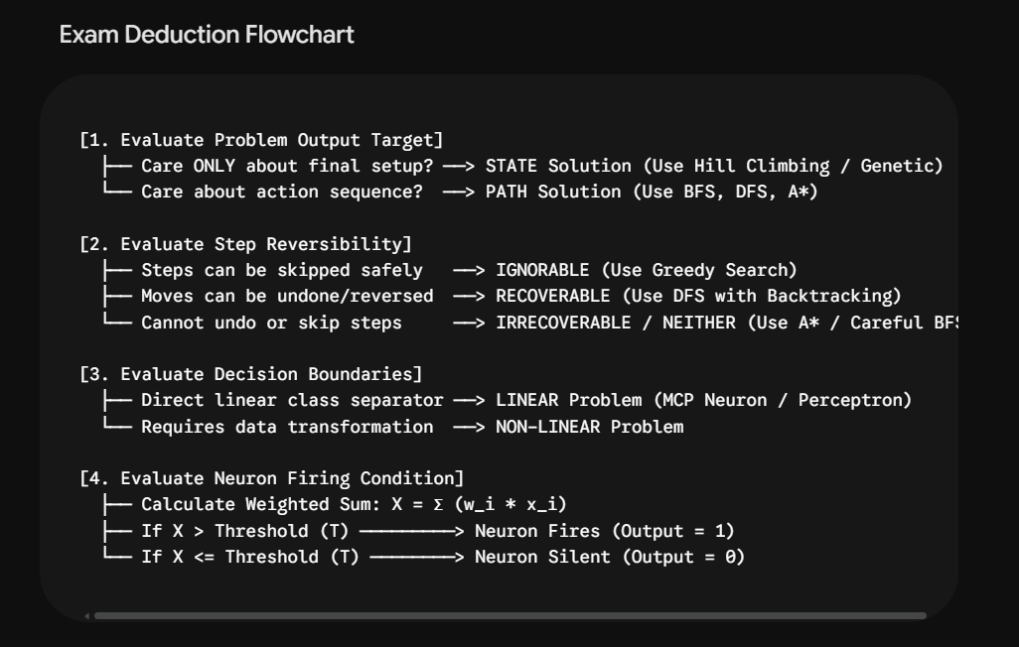

4. Search in AI
Searching is the universal technique for problem-solving in Artificial Intelligence. A search problem is formally mapped through specific structural components:

- State Space: The set of all possible states where an agent can potentially exist.

- Start State: The initial state from which the search process originates.

- Actions: Descriptions of all valid moves or operations accessible to the agent.

- Transition Model: A formal function defining the outcome state resulting from applying a specific action to a given state.

- Goal Test: A boolean evaluation function that checks whether a candidate state matches the goal conditions.

- Path Cost: A function that assigns a numeric cost to a given sequence of steps.

- Solution: A sequence of actions (a plan) that transforms the start state into a valid goal state.

- Optimal Solution: A solution sequence that achieves the lowest path cost among all viable paths.

- Search Tree: A tree-based graph structure representing the search space, rooted at the node corresponding to the initial state.

Generic Search Algorithm
Plaintext
1. Initialize the search tree using the initial state of the problem.
2. Repeat:
a. If no candidate nodes remain for expansion, return FAILURE.
b. Select a leaf node for expansion according to the chosen search strategy.
c. If the node satisfies the Goal Test, return the corresponding PATH solution.
d. Otherwise, expand the node by:
- Applying each valid operator
- Generating the corresponding successor states
- Adding the resulting nodes to the search tree.
(Algorithm structure derived from problem context)

2. Problem Categorization: Toy vs. Real-World Problems
Problem formulations in AI are categorized into two primary domain types:

- Toy Problems: Controlled, abstract environments designed specifically to benchmark or illustrate problem-solving strategies. They feature exact specifications and known boundary conditions.

- Real-World Problems: Practical problems that fulfill real-world operational needs. They generally lack a single standard specification, are subject to dynamic real-time constraints, and carry significant economic value.

Feature | Toy Problems (e.g., 8-Puzzle) | Real-World Problems (e.g., TSP)
Description | Exact, universally agreed-upon specification. | Varies heavily depending on operational context.
State Space | Finite and computationally manageable. | Exponentially large or unbounded.
Optimal Solution | Guaranteed by standard exact search algorithms. | Generally NP-hard to guarantee.
Real Value | Educational benchmarks and algorithmic testing. | High stakes with massive economic/financial impact.
Constraints | Static, fully known in advance. | Dynamic, multi-factor, and changing over time.
3. Case Studies in Problem Formulation
Case Study A: The 8-Puzzle (Toy Problem)
- State Description: Location of each of the 8 numbered tiles and the single blank space across a $3×3$ grid.

- Initial State: Any defined configuration of tiles ($\frac{9!}{2}$ solvable states).

- Actions: Moving the blank space $\left\{\text{Left},\text{Right},\text{Up},\text{Down}\right\}$.

- Transition Model: Returns the new tile configuration resulting from a specified move.

- Goal Test: Evaluates whether the grid matches the designated target layout.

- Path Cost: Each step incurs a uniform cost of 1.

- Complexity: Formally classified as an NP-Complete problem.

Case Study B: Traveling Salesman Problem / TSP (Real-World Problem)
- Problem Statement: Given a set of cities and pairwise distances, find the shortest route that visits every city exactly once and returns to the home city.

- Combinatorial Complexity: For a symmetric TSP with $n$ cities, the number of distinct routes is $\frac{\left(n-1\right)!}{2}$. Factorial growth renders brute-force evaluation impossible for large values of $n$.

- NP-Hardness & Practice: Proving whether an efficient polynomial-time algorithm exists is tied directly to the $P\text{ vs }NP$ problem. In practical settings:

  - Approximations & Heuristics: Used to compute near-optimal routes rapidly.

  - Exact Methods: Advanced branch-and-bound techniques can solve instances up to ~100,000 cities, requiring heavy optimization and computation time.

- Real-World Applications:

  - Logistics & Delivery: Routing fleets (e.g., FedEx, UPS, Amazon), where 1% route optimization saves millions annually.

  - PCB Drilling: Minimizing industrial drill-head movement across circuit board hole layouts.

  - DNA Sequencing: Assembling overlapping DNA fragments into a sequence using shortest superstrings.

  - Airline & Fleet Scheduling: Minimizing transit times, fuel consumption, and crew positioning costs.

  - Warehouse Robotics: Route optimization for order-picking robots on warehouse floors.

  - Telescope Scheduling: Minimizing slewing time between sky target observations.

4. Search Paradigms: Uninformed vs. Informed Search
AI Search Algorithms
|
+-------------------------+-------------------------+
| |
Uninformed (Blind) Search Informed (Heuristic) Search
- Uses state space rules only - Uses domain knowledge / h(n)
- No distance estimations - Evaluates state "goodness"
- Examples: BFS, DFS, UCS, DLS - Examples: Best-First, A*
Uninformed (Blind) Search
- Operates strictly using state definitions, successor generations, and goal test conditions without domain-specific distance metrics.

- Primary traversal methods include Breadth-First Search (BFS), Depth-First Search (DFS), Uniform-Cost Search (UCS), Depth-Limited Search (DLS), Iterative Deepening DFS (IDDFS), and Bidirectional Search.

Informed (Heuristic) Search
- Incorporates domain-specific knowledge to evaluate which non-goal states are most promising.

- Utilizes a Heuristic Function $h\left(n\right)$ that estimates the minimal path cost from node $n$ to a target goal state.

Properties of the Heuristic Function $h\left(n\right)$:
- Goal Distance Estimation: Accepts current state information as input and outputs a positive numeric value representing estimated remaining path cost.

- Efficiency Trade-off: May not guarantee optimal solutions under all configurations without specific conditions (e.g., admissibility), but guarantees near-optimal solutions efficiently.

5. Comparative Evaluation of Core Search Algorithms
Algorithm | Search Type | Complete | Optimal Solution | Time Complexity | Space Complexity | Primary Advantage | Primary Disadvantage
Breadth-First Search (BFS) | Uninformed | Yes | Yes | High | High | Guarantees shortest path for uniform costs. | High memory consumption.
Depth-First Search (DFS) | Uninformed | No | No | Moderate | Low | Low memory footprint. | Can get trapped in infinite or non-optimal deep paths.
Best-First Search | Informed | No | No | Moderate | Moderate | Generally faster traversal than BFS. | No guarantee of finding an optimal path.
A Search Algorithm* | Informed | Yes | Yes | Moderate | Moderate to High | Optimal and efficient using appropriate heuristics. | Performance relies heavily on heuristic design.

📊 Uninformed (Blind) Search Algorithms
These rely only on the problem definition (initial state, goal state, actions) without heuristics.
Algorithm | Strategy | Completeness | Optimality | Time Complexity | Space Complexity | Notes
Breadth-First Search (BFS) | Level-order using queue | ✅ Yes | ✅ Yes (if uniform cost) | $O\left(b^{d}\right)$d= depth of shallowest solution and b is a node at every state | $O\left(b^{d}\right)$Memory size of frontier | Finds shortest path in steps.
Depth-First Search (DFS) | Deep exploration using stack | ✅ Yes (finite) | ❌ No | $$O\left(b^{m}\right)$$ | $$O\left(bm\right)$$ | May get stuck in infinite depth.
Depth-Limited Search (DLS) | DFS with depth cutoff | ✅ Yes (if cutoff ≥ d) | ❌ No | $$O\left(b^{l}\right)$$ | $$O\left(bl\right)$$ | Useful when depth bound known.
Iterative Deepening DFS (IDDFS) | Repeated DFS with increasing depth | ✅ Yes | ✅ Yes | $$O\left(b^{d}\right)$$ | $$O\left(bd\right)$$ | Combines BFS completeness with DFS space efficiency.
Uniform-Cost Search (UCS) | Expands lowest path cost | ✅ Yes | ✅ Yes | $$O\left(b^{1+\left\lfloor C^{*}/ϵ\right\rfloor }\right)$$ | Same order | Best for weighted graphs.
Bidirectional Search | Search forward & backward | ✅ Yes | ✅ Yes | $$O\left(b^{d/2}\right)$$ | $$O\left(b^{d/2}\right)$$ | Very efficient if goal known.
🎯 Heuristic (Informed) Search Algorithms
These use heuristics (extra knowledge) to guide exploration.
Algorithm | Strategy | Completeness | Optimality | Time Complexity | Space Complexity | Notes
Greedy Best-First Search | Expands node with lowest heuristic $h\left(n\right)$ | ✅ Yes | ❌ No | $$O\left(b^{m}\right)$$ | $$O\left(b^{m}\right)$$ | Fast but not optimal.
A\* | Expands node with lowest $f\left(n\right)=g\left(n\right)+h\left(n\right)$ | ✅ Yes (if heuristic admissible) | ✅ Yes (if heuristic admissible & consistent) | $O\left(b^{d}\right)$worst case | $$O\left(b^{d}\right)$$ | Gold standard for optimal search.

Adversarial Search
Adversarial search is a search, where we examine the problem which arises when we try to plan ahead of the world and other agents are planning against us.
The environment with more than one agent is termed as multi-agent environment, in
which each agent is an opponent of other agent and playing against each other. Each
agent needs to consider the action of other agent and effect of that action on their
performance.
So, Searches in which two or more players with conflicting goals are trying to
explore the same search space for the solution, are called adversarial searches, often
known as Games.

Types of Games in AI:
o Perfect information: A game with the perfect information is that in which agents can look into the complete board. Agents have all the information about the game, and they can see each other moves also. Examples are Chess, Checkers, Go, etc.
o Imperfect information: If in a game agents do not have all information about the game and not aware with what's going on, such type of games are called the game with imperfect information, such as tic-tac-toe, Battleship, blind, Bridge, etc.
o Deterministic games: Deterministic games are those games which follow a strict pattern and set of rules for the games, and there is no randomness associated with them. Examples are chess, Checkers, Go, tic-tac-toe, etc.
o Non-deterministic games: Non-deterministic are those games which have various unpredictable events and has a factor of chance or luck. This factor of chance or luck is introduced by either dice or cards. These are random, and each action response is not fixed. Such games are also Example: Backgammon, Monopoly, Poker, etc.

Constraint Satisfaction Problems (CSP) in AI

A Constraint Satisfaction Problem is a mathematical problem where the objective is to assign values to variables such that all the constraints are satisfied.
Many AI applications use CSPs to solve decision-making problems. Common applications of CSPs include:
- Scheduling: It assigns resources like employees or equipment while respecting time and availability constraints.
- Planning: Organize tasks with specific deadlines or sequences.
- Resource Allocation: Distributing resources efficiently without overuse
Components
1. Variables: Things we need to find values for. For example, in a Sudoku puzzle each empty cell is a variable that needs a number.
2. Domains: The set of possible values that a variable can have. In Sudoku the domain for each cell is the numbers 1 to 9.
3. Constraints: The rules that restrict how variables can be assigned values. There are different types of constraints:
- Unary: Apply to a single variable like "this cell cannot be 5".
- Binary: Involve two variables like "these two cells cannot have the same number".
- Higher-order: Involve three or more variables like "each row in Sudoku must have all numbers from 1 to 9 without repetition".
Types
CSPs can be classified based on the number and importance of their constraints:
- Binary CSPs: Each constraint involves only two variables. Like in a scheduling problem the constraint could specify that task A must be completed before task B.
- Non-Binary CSPs: Involve more than two variables. For instance in a seating arrangement problem a constraint could state that three people cannot sit next to each other.
- Hard and Soft Constraints: Hard constraints must be strictly satisfied while soft constraints can be violated but at a certain cost. This is often used in real-world applications where not all constraints are equally important.

